Newark Country Club
Presents
Summer Classic Car Show
Saturday, June 13, 2015
2:00 -4:00 pm
Automotive enthusiasts are invited to cruise-in to NCC

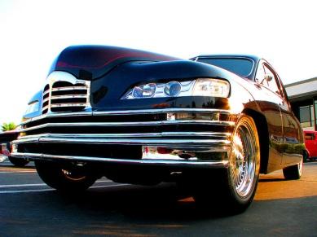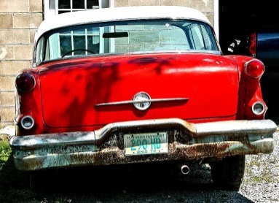

BBQ ~ Cash Bar
45 spots available
Newark CC 300 W. Main Street. Newark, De 19711
To reserve a spot call or email Laura DelPercio ldelpercio@newarkcc.com
302-731-4251

